Limit of a Function: The notation means that as x approaches the value a f(x) approaches L

Note-Abbreviation: DNE means does not exist.

Discontinuity: A point in an interval for which the function is discontinuous.

Definition of Continuity at a Point: A function f is considered continuous at c when

1. f(x) is defined
2. exists

Properties of Limits: Given real numbers b and c, positive number n and functions f and f with limits and , we may find the following:

Constant Property: If the equation of f(x) is a constant the limit of any value of c, will equal the constant.

Scalar Property: Given scalar b,

Sum/Difference Property:

Product Property:

Quotient Property: , if k ≠0.

Power Property: , if n is a positive integer or if L > 0

Transcendental Functions: Functions that are not rational functions or polynomial functions. An example of a transcendental function is sin(x) or ln(x).

Epsilon-Delta Notation: A notation for limits where one specifies for the x-range of the limit (notated by δ), that the y-values will be within a range (notated by ε), this is such that that the following inequalities may be defined: 0 < |x-a| < δ, |f(x) – L| < ε.

Types of Discontinuity: Given the definition of discontinuity, we may sort discontinuities such that they fall into several groups, below are a few:

Infinite Discontinuity: A discontinuity where values approaching the discontinuity approach ±infinity. Vertical asymptotes of rational functions are examples of these.

Removeable Discontinuity: A discontinuity where a function approaches a defined value, but it is discontinuous at that point. In terms of limits, if c is the point in question, the limit of f(c) exists, however, f(c) does not exist, and since it does not the limit f(c) obviously does not equal f(c) as is necessary for continuity to exist at c.

Jump Discontinuity: A discontinuity where the one sided limits of a value exist and are not equal to each other, this often occurs in piece-wise defined functions.

Squeeze Theorem: Given an inequality x ≥ y ≥ z, if x = z, then y = x = z.

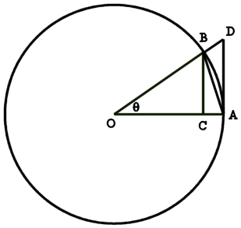Proof of :

Given the diagram shown to the right, we can determine that the triangle ABO has an area of (its height is sin(x)), we can also determine the Sector AB has an area of () and the triangle ADO has an area of (its height is tan(x)). After finding the areas of these triangles we can order then in an inequality, || < | | < ||. We can simplify this inequality by multiplying it by || to get 1 < < . We can then invert the inequality and get 1 > > cos(x), since cos(x) moves towards 1 the closer x is to 0 we can then use the squeeze theorem to say that the .

One Sided Limits: Given we can say from the ‘right’ side of a f(x), conversely given we can say that from the left side of a f(x) approaches L.

Relationship of One Sided Limits to Normal Limits: If the exists then one may say that both of the one-sided limits related to a also exist and are equal to L. The converse is also true, if both one-sided limits exist and approach the same value.

Rationalising Discontinuities: Given ,

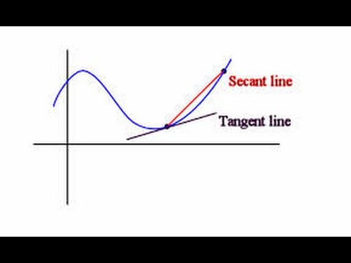Derivative: The instantaneous slope (or rate of change) of a function.

Equation of a Derivative: Given an equation f(x) the equation of the tangent line can be found by using the generalized form of the limit of the slope of the secant line as delta(X) approaches 0. If we denote delta(X) as h we find the slope of any secant line of a function will be which can be simplified to which once we take the limit of this equals the equation which is the definition of a derivative.

Example of Taking a Derivative Using the Equation of a Derivative: Let us take the derivative of the equation x2. If we use the points (x,f(x)) and (x+h,f(x+h)) in our example then our slope will be we can then simplify this to this then may be simplified to which may be simplified to 2x as we are looking for the limit of the slope as h approaches 0 which means the derivative of x2 is 2x.

Power Rule of Derivatives: Given an expression of the form of axb we find that the derivative of the expression is equal to abxb-1.

Notations of Derivatives: There are several ways to express a derivative, commonly used is or both of which denote the derivative of a function.

Distribution of a Derivative: Given an expression we find that it is equivalent to . In addition, given the expression we find it equivalent to .

Derivative of a Polynomial: When taking the derivative of a polynomial you distribute the derivative to each of the polynomial’s individual terms. Ex: x2 + x + 1, after taking its derivative we find it to be which equals 2x+1.